Case Study of
Flappy Bird

Game Overview

Flappy Bird is a mobile arcade game developed by Dong Nguyen that gained worldwide popularity due to its simplicity and challenging gameplay and loop. In this case study, the game is analyzed in terms of its gameplay mechanics, visual presentation, controls, and overall player experience. Although it appears to be a very mini game, Flappy Bird shows how the game gain a massive fame in worldwide variety of mobile gaming community.
The gameplay of Flappy Bird revolves around a single mechanic: tapping the screen to make the bird flap upward. When the player does not tap, the bird will fall down and ending the game. The player must avoid the approaching pipe by going through. A single collision with a pipe or the ground ends the game immediately. This one-hit game-over system heightens the tension and demands precise timing from the player. Because of its simple controls, players can start playing instantly, yet the difficulty ensures that mastering the game is extremely challenging.
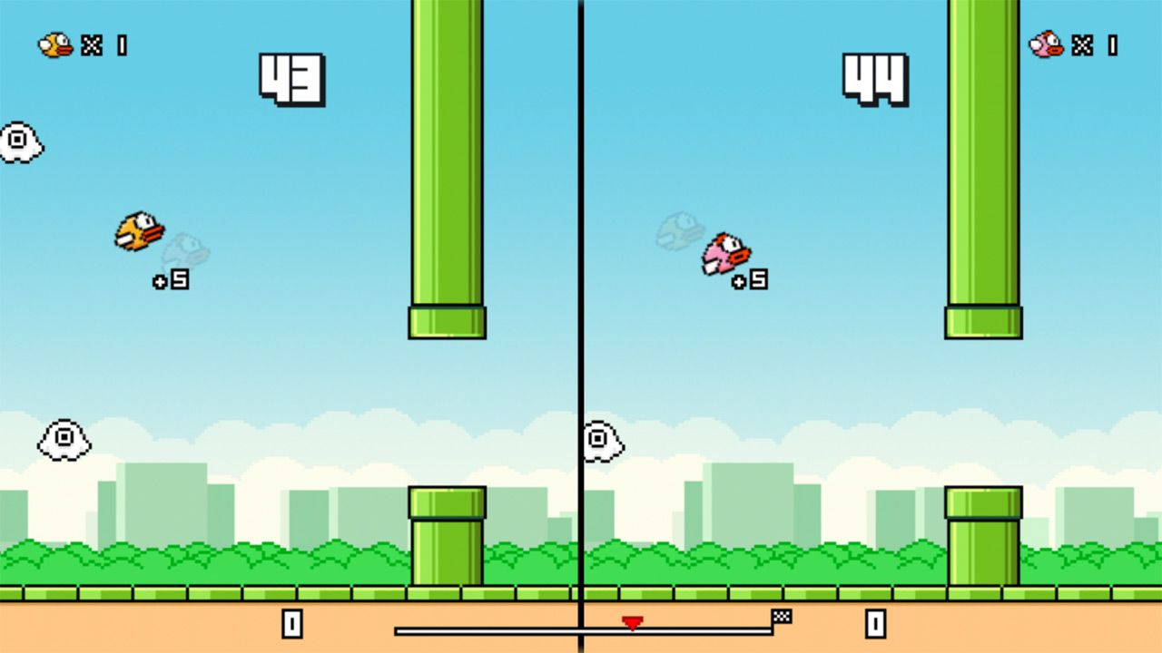
Visually, Flappy Bird adopts a retro pixel-art aesthetic inspired by early video games. The graphics are intentionally basic, featuring a bright sky background , it can be also change every time the player repeats the game, repeating ground textures, and green pipes reminiscent of classic platformer games. This little approach contributes to the game’s accessibility, allowing it to run smoothly on almost any mobile device. The sound effects are equally simple, consisting of flap sounds, score chimes, and a short game-over menu for player to show their score and badges , and also a button to quit or restart.

Why Dong Nguyen decided to remove the game from app store?

Flappy Bird was removed by its creator, Dong Nguyen, because he felt immense guilt over the game’s addictive nature and the negative impact it had on some players’ lives. He had originally designed it as a simple, casual game but was overwhelmed by its viral success and the negative attention it brought him, including constant media requests and online harassment, which led to him losing sleep.

“I can call ‘Flappy Bird’ is a success of mine. But it also ruins my simple life. So now I hate it. It is not anything related to legal issues. I just cannot keep it anymore. I also don’t sell ‘Flappy Bird’, please don’t ask.”

Game Mechanics and Elements
The core mechanics of Flappy Bird revolve around simple tap-based controls and constantly moving obstacles. The player taps the screen to make the bird flap, giving it a quick upward impulse while the bird falls downward between taps. Although the bird itself doesn’t move forward, the background and pipes scroll left at a steady speed, creating the illusion of flight. Pipes spawn in pairs : one on top and one on the bottom , with a randomized vertical gap position and a fixed gap size to control difficulty, appearing at regular intervals of about 1.2 seconds before being removed once they move off-screen. The game ends immediately when the bird collides with a pipe, the ground, or in some versions, the ceiling, using basic collision detection through bounding boxes or circles. Scoring is straightforward: the player gains one point each time the bird successfully passes through a pair of pipes, usually triggered when the pipes cross the bird’s horizontal position.

Gameplay Loop

The gameplay loop of Flappy Bird is very straightforward but addictive. When the game starts, the player sees the bird on the screen, usually hovering above the ground with the background and pipes in place. At this point, the game is idle and waits for the player to tap the screen to make the bird start moving.

Once the player taps, the bird “flaps” upward, and falling begins. The player’s input controls the bird’s vertical movement, while the game continuously applies downward force, making timing and rhythm very important. Pipes start scrolling from the right side of the screen toward the left, creating obstacles that the player must navigate. Each pair of pipes has a gap at a random vertical position, which keeps the challenge unpredictable.

As the bird moves forward, the game constantly checks for collisions. If the bird hits a pipe or the ground, the game ends. The player’s score increases every time the bird successfully passes through a pair of pipes. The score is updated in real-time and displayed on the screen, giving instant feedback to the player.

When the game ends, a “Game Over” screen appears showing the final score, and the player can choose to restart the game. Restarting resets the bird’s position and score, returning the game to its initial idle state. This cycle of starting, controlling the bird, avoiding obstacles, and either scoring or crashing forms the core loop of Flappy Bird, keeping the gameplay simple yet challenging.

Difficulty Curve

Flappy Bird’s difficulty is the defining characteristic that made it both infamous and addictive. Despite having simple one-tap controls, the game presents an extraordinarily challenging experience that frustrated millions of players worldwide. The combination of harsh game mechanics and pressure factors creates a uniquely punishing gameplay experience where even experienced players struggle to surpass basic scores.

The gaps between pipes are wide, but the bird moves so fast Players must maintain the bird at a specific height range, but the jumpy nature of the flapping mechanic makes precise positioning extremely difficult. There’s no gradual learning curve with easier levels the difficulty remains consistently high from the very first pipe.

Any contact with pipes, the ground, or the ceiling results in immediate game over. There are no health bars, shields, or second chances. This one hit kill system means that even after achieving a high score, a single mistake resets all progress.

The vertical positioning of pipes varies randomly, preventing players from memorizing patterns or developing muscle memory. Each playthrough presents new challenges requiring constant adaptation.

Fun Factor
The fun factor of Flappy Bird comes from its simple but highly challenging gameplay that keeps players engaged and motivated to try again. The game uses easy one-tap controls, making it very accessible, yet the increasing difficulty creates a strong sense of competition and personal improvement . Nostalgia Factor many players found nostalgia in Flappy Bird’s retro style reminiscent of classic games from earlier gaming eras. Its pixelated graphics evoke memories of simpler times in gaming history when fun was often derived from skill rather than visuals or storylines alone. In today’s world filled with 3D graphics and complex narratives, this throwback was refreshingly appealing for many gamers seeking old school charm.
The gaps were invitingly wide, many times the height of the bird. But because the bird moved so fast and dove up and down so quickly, making it through the gap without wiping out proved extremely challenging. Because you get just one point for each pipe cleared, your high score is likely to be in single digits, if not zero. Flappy Bird also tapped into social competitiveness by allowing players to share their scores on social media platforms. As friends compared scores, it fostered a sense of community around the game , everyone wanted bragging rights over who could achieve higher scores or survive longer in game. This competitive element not only increased engagement but also propelled downloads as friends encouraged one another to try their hand at beating respective records.
‎In summary, Flappy Bird’s captivating gameplay lies in its minimalist design, intuitive controls, challenging nature, social competitiveness, and nostalgic appeal all contributing factors that launched this humble mobile game into global popularity. By stripping away excessive complexity while maintaining engaging challenges and fostering community interaction among players, Flappy Bird exemplifies how sometimes less really can be more.

Improvement Ideas
- Flappy Bird can be improved by adding stars or rewards after passing obstacles.
- Customizable skin so the player wont just see just one simple bird when playing and attract many player.
- Add New levels and Background scenery of the game
- Additional Levels and Challenges (Obstacles)

Appendix
https://www.reference.com/pets-animals/flappy-bird-s-simple-gameplay-captivated-millions-players
https://www.wired.com/2014/02/flappy-bird/
https://salientpr.com/blog/therealstorybehindwhyflappybirdwasdeleted

